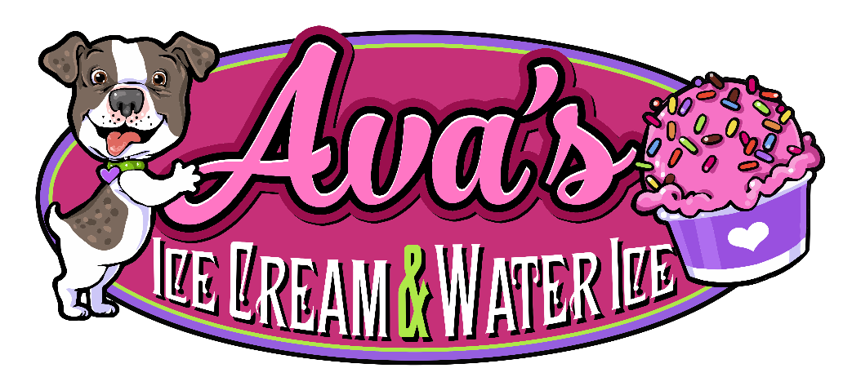

HELP WANTED
ICE CREAM SCOOPER
16 YEARS AND OLDER
PART TIME NIGHTS AND WEEKENDS
APPLY WITHIN

AVA’S ICE CREAM AND WATER ICE
3801 GREMANTOWN PIKE
COLLEGEVILLE, PA 19426

